Lexis Advance reveals that from 1833 to 2018, 346 cases originated in Arkansas (either state, federal or territorial) courts and ended up at the United States Supreme Court. The following partial list indicates the cases that are the most interesting, significant or noteworthy.

**************

Sampeyreac v. United States, 32 U.S. 222 (1833) (from a territorial court; fictitious person)

Glenn v. United States, 54 U.S. 250 (1852) (Demand for 500,000 acres based on 1794 Spanish land grant)

McAffee v. Crofford, 54 U.S. 447 (1852) (taking slaves from an Arkansas plantation)

McRea v. Bank of Alabama, 60 U.S. 376 (1856) (promissory note for slaves)

Hanger v. Abbott, 73 U.S. 532 (1867) (statutes of limitations during the Civil War)

Osborn v. Nicholson, 80 U.S. 654 (1871) (contract for sale of slave)

Hanauer v. Woodruff, 82 U.S. 439 (1872) (validity of Confederate bonds)

Ross v. Jones, 89 U.S. 576 (1874) (statute of limitations during war)

Hall v. United States,150 U.S. 76 (1893) (prejudicial closing arguments

Allis v. United States, 155 U.S. 117 (1894) (bank fraud)

Allen v. United States, 164 U.S. 492 (1896) (the “dynamite charge”)

Moore v. Dempsey, 261 U.S. 86 (1923) (Elaine massacre of 1919; habeas corpus after murder conviction in state court)

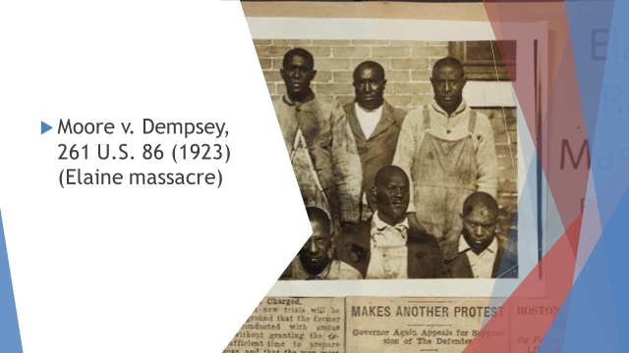

Arlington Hotel v. Fant, 273 U.S. 439 (1929) (guests at hotel suffered damage to their personal property caused by fire)

Superior Bathhouse v. McCarroll, 312 U.S. 176 (1941) (state tax on federal bathhouse)

State of Arkansas v. State of Texas, 346 U.S. 368 (1953) (contract; University of Arkansas brings an original action against the State of Texas)

Cooper v. Aaron, 358 U.S. 1(1958) (Little Rock desegregation)

Shelton v. Tucker, 364 U.S. 479 (1960) (loyalty oath for teachers)

Hamm v. Rock Hill; Lupper v. State of Arkansas, 379 U.S. 306 (1964) (conviction for sitting at a lunch counter in Blass Department Store in Little Rock)

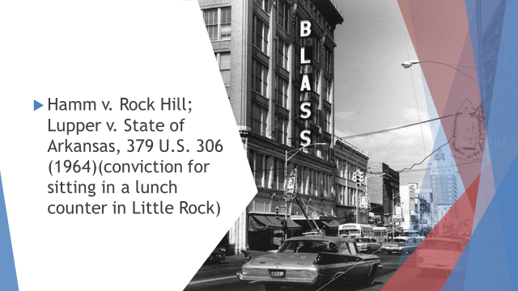

Epperson v. Arkansas, 393 U.S. 97 (1968) (statute banning the teaching of evolution)

Arkansas v. Tennessee, 397 U.S. 88 (1970) (boundary dispute)

Mississippi v. Arkansas, 415 U.S. 289 (1974) (boundary dispute)

Hutto v. Finney, 437 U.S. 678 (1978) (cruel and unusual punishment; Arkansas prison system)

Arkansas v. Sanders, 442 U.S. 753 (1979) (search of taxicab)

Hill v. Lockhart, 474 U.S. 52 (1985) (guilty plea; ineffective assistance of counsel)

Rose v. Arkansas State Police, 479 U.S. 1 (1986) (Arkansas workers’ compensation and federal Public Safety Officers’ Death Benefits Act)

State of Arkansas v. Cherokee Nation of Oklahoma, 480 U.S. 700 (1987) (damage to riverbed and federal government’s navigational servitude)

Arkansas Writers’ Project, Inc. v. Ragland, 481 U.S. 221 (1987) (sales tax on magazines and the First Amendment)

Rock v. Arkansas, 483 U.S. 44 (1987) (hypnotically refreshed testimony)

Lockhart v. Nelson, 488 U.S. 33 (1988) (double jeopardy)

American Trucking Associations v. Smith, 496 U.S. 167 (1990) (highway use taxes and the Commerce Clause)

Leathers v. Medlock, 449 U.S. 349 (1991) (sales tax on cable television services and the First Amendment)

U.S. Term Limits, Inc. v. Thornton, 514 U.S. 779 (1995) (Arkansas constitutional amendment setting term limits for Members of Congress)

Clinton v. Jones, 520 U.S. 681 (1997) (tort claim against the President)

Arkansas Educational Television Commission v. Forbes, 523 U.S. 666 (1998) (exclusion of candidate for Third Congressional District from television debate)

Arkansas v. Sullivan, 532 U.S. 769 (2001) (search and seizure)

Rousey v. Jacoway, 544 U.S. 320 (2004) (Individual Retirement Accounts and bankruptcy)

Jones v. Flowers, 547 U.S. 220, (2006) (Due process and notice in tax delinquency proceeding)

Arkansas Department of Health and Human Services v. Ahlborn, 547 U.S. 268 (2006) (Medicaid lien)

Blueford v. Arkansas, 566 U.S. 509 (2012) (double jeopardy)

Miller v. Alabama; Jackson v. Hobbs; 567 U.S. 460 (2012) (life without parole for a juvenile)

Holt v. Hobbs, 135 S. Ct. 853 (2015) (facial hair; Religious Land Use and Institutionalized Persons Act)

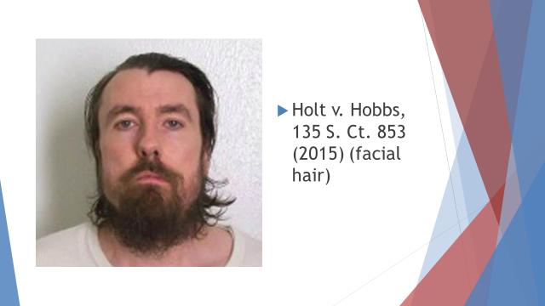

Pavan v. Smith, 137 S. Ct. 2075 (2017) (birth certificate for same sex parents)

***************

Note: The research skills of Catherine Chick, Associate Law Librarian, located these cases. I am grateful for her dedicated work on this project.

