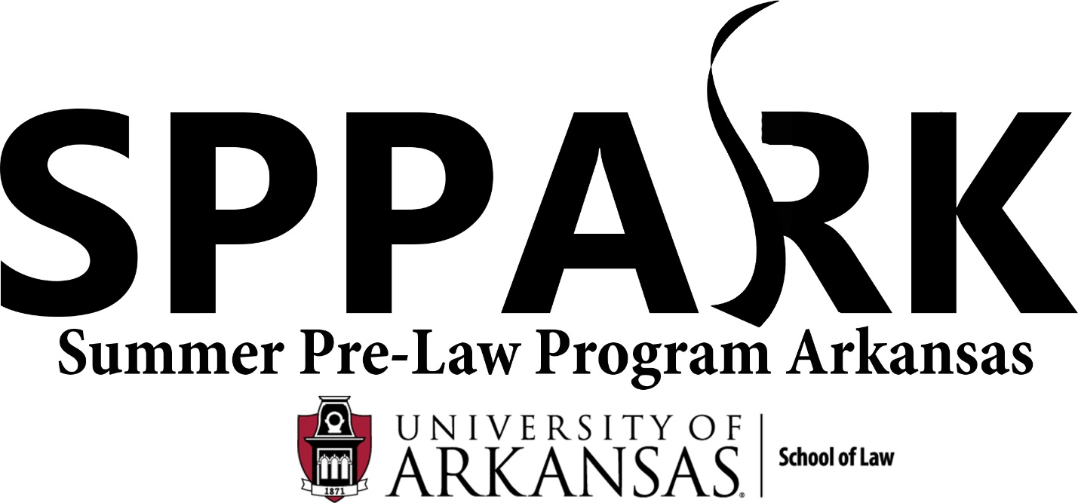

ORIENTATION AGENDA
May 22, 2017
Law School Room 342

4:00 Welcome and Introduction of Faculty and Staff: Stacy Leeds, Dean
4:20 Introduction by SPPARK Participants
4:50 Discuss Purpose of the Program Handbook: Dean Lewis
4:55 Break
5:05 Review of Program Handbook
I. Campus Policies and Program Expectations: Dean Lewis
-Notice of Nondiscrimination
-Notice of Policy against Sexual Harassment
-Accommodation Requests
-Dietary Restrictions
-Expectations of Participants

II. Overview of Academic Course: Dean Leeds
-Legal Writing
-Oral Advocacy

Erik Schneider and Jared Perry, TAs to the Dean:
-Expectations of the Teaching Assistants
-Timeline and due date for paper
-Oral advocacy preparation and expectations
-Faculty Awards at Graduation (Best Oralist, etc.).

Deborah Moore, Senior SPPARK TA, and Jennifer Hosp, SPPARK TA:
-How to Write a Case Brief
-Student Awards at Dean’s BBQ (Most likely to succeed, etc.).

III. Code of Conduct: Dean Lewis
-Termination
-Withdrawal
-Session Conduct, the Points System and Penalties
-Medical Exemptions
-Probation
-Prohibition of Outside Coursework

IV. Housing: Dean Lewis
-Rules and Regulations
-Prohibited Materials
-Tobacco Policy
-Inspection and Access
-Security
-Pat Walker Health Center
-University of Arkansas Police Department

V. Waivers: Dean Lewis
-Liability Waiver
-Medical Emergencies

5:55 Closing Remarks: Dean Leeds
6:00 Leave for PIKE

